ELECTIONS - EKLOGEZ

Part 2

DIMOTIKES EKLOGEZ / LOCAL ELECTIONS

General information:

- For the island of Zakynthos there are 9 combinations for the dimos. For the dimos of Zakynthos plus for the forty-seven [47] communities there are a total of 585 candidates.

- 105 polling stations have been set up on the island. Of these, 29 sections are single (that is, elections for the members of the European Parliament, regional and municipal elections, as well as elections for the appointment of councillors or presidents of communities will be held in one, single polling station).

- In the remaining 76 polling stations, voting for the members of the European Parliament and regional elections will take place in room ‘A’, while voting for municipal elections and community councillors or the president of the community, will take place in room ‘B’.

- The total number of voters is 42.044. 105 persons from ‘other’ dimos / municipalities will vote only for the European elections, while there are 344 European Community voters.

- A decision of the Minister of Interior defines the number of municipal councillors in each constituency, based on its permanent population, as shown by the latest census. Zakynthos elects a total of 33 municipal councillors, shared -
Alykes municipal unit - 5.203 inhabitants and 4 councillors,
Arcadia municipal unit – 5.215 inhabitants and 4 municipal councillors,
Artemisia municipal unit - 4.612 inhabitants and 4 councillors,
Elation municipal unit – 1.933 inhabitants and 1 counsellor,
Zakynthos municipal unit – 16.810 inhabitants and 14 councillors
Laganas municipal unit – 6.986 inhabitants and 6 councillors.

Introduction
All candidates say that their main concerns are for:
- the final solution for integrated waste management with the construction of a mechanical treatment and recycling ,
- the intensive implementation of sorting at source, recycling, household and commercial composting, integrated into an operational programme in the region,
- the restoration of the closed landfill site of Skopos,
- developing an integrated waste-water management plan (master plan) across the island.
Other points are
- the expansion of the sewage treatment plant to double the capacity of day-to-day sewage treatment,
- extending the sewage network of the town of Zakynthos,
- the integrated operation of the Kalamaki sewage network,
- water resource management for effective and permanent solutions. Water management of the island pre-supposes projects of surface water exploitation (reservoirs, dams) and enrichment of the aquifer. So water, as a collective good, will be delivered to all with constant flow and good quality.

The 9 combinations with their leader, mayoral candidate, are -

"ANADRASI 2019 / Pre-action 2019"
led by Yiannis Agalianos.

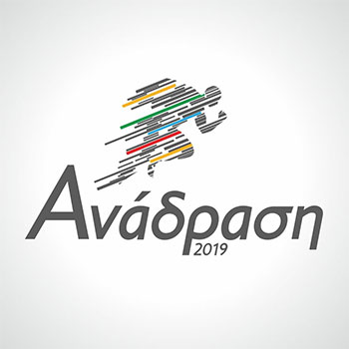

Mr Agalianos is not new to Zakynthos, in terms of local administration, having previously served as mayor from 1999 to 2002. The team consists of candidates with experience and new blood.
‘Our’ Maria Droggitis is a candidate for councillor, as is Nick Tsipiras – known for his presence on Island fm, with Bobby Gee, in relation to the problems with the rubbish over the last three winters.
Targets are:
An electronic municipality that can serve the citizen from his home.
Sport and culture.
Katastari and the surrounding areas, need to be re-developed.
We are against desalination.
Pollution of the environment needs to be solved.
On the subject of roads – potholes need to end, trees on the roadside that block vision and are dangerous, a need to widen the old roads, as well as to open a new road from the ERA radio station at Mouzaki to Agia Eleni at Sarakinado, a road needs opening from the airport to Kalamaki and Laganas.
We want the reform from Kryoneri and EOT beach along the coastal road, which will include a pedestrian & cycle pathways and tree planting. We need co-negotiation and agreement with the Port Authority and the Land Service.
We will also re-develop the area of the traditional Kaminia, Bohalis, but also in the area of Agios Dionysios, where the centre of town will be transferred in the future. Only then will we have a modern town, but at the same time with traditional colour.
Council meetings will stop being hosted at the Cultural Centre instead they will be held in the Town Hall building on the top floor. The Cultural Centre will be renovated.

"ZAKYNTHOS ANATROPEE ANAYENNISI / Overthrow for the rebirth of Zakynthos"
led by Antonis Kassimatis.

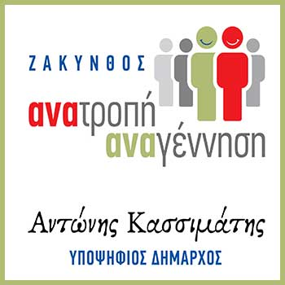

Mr Kassimatis created the Cardiology Clinic at the Hospital of Zakynthos.
Head of the minority, of the present dimos/municipal council.
His priorities are, other than those mentioned in the introduction, -
Restoration of public spaces and installation of playgrounds.
Implementation of interventions for earthquake-proofing of school buildings.
Re-operation of KAPI and actions to create KAPI in the villages. (Kapi = Oap).
Centering on the human approach to the town, equal access for all citizens and visitors alike.
Operation of the Municipal Theatre.
Establishment of a shelter for the care of stray animals on a property of the Municipality.
Creation of cultural routes throughout Zakynthos.
Ensure conditions for reinstating Blue Flags.
The instant operation of a modern slaughterhouse.
Implementation of a plan to organize flexible urban transport in cooperation with the Ktel buses.
Installation of a special telephone hotline with the services of the Municipality.

"ENOTIKI ZAKYNTHINI KINISI / Uniting Zakynthos Movement"
led by Dionysis Gasparos.

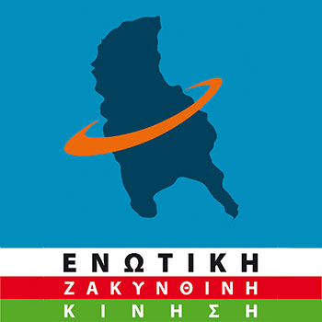

Previously ‘Nomarhos’ from 1999 to 2010. (when Zakynthos had an unusually large number of blind people).
Mr Gasparos is a doctor, Urologist.
‘Our’ Penny Draper is a candidate councillor with Mr Gasparos’ combination.
Mr Gasparos set as a priority the improvement of social structures and social protection in the municipality, and announced the creation of municipal clinics, where at no cost, the economically weak citizens will be cared for.
The establishment of support structures for cancer patients as well as drug dependents with problems of integration and care.
A comprehensive programme of reconstruction of the shipwreck area in cooperation with the church and the relevant services, such as the forest service, sustainable land and its redeployment.
The support of the Upper Region communities of Zakynthos.
The creation of 12-month jobs for the inhabitants of the Upper Region areas.
The protection of the environment and the forests wealth.
The support of the re-planning of a rational projection of the National Marine Park of Zakynthos and its wealth.

“EPPANAKINISI TORA / Restart Now”
led by Haralambos Liveris.

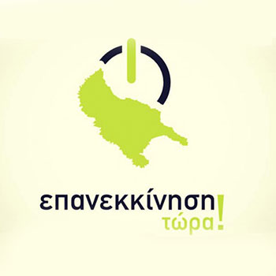

From Agios Leontas. Businessman. Created the Athletic club Leon that concerns boxing and martial arts. Twice national coach in the Greek Martial Arts Federation. Willing to give his mayors pay to local social activities.
Mr Liveris’ targets for the dimos / municipality should his combination be voted in –
Digitizing the networks and services of the Municipality.
Strengthening social structures.
Reinforcement of the financing of school buildings and sports facilities.
Animal welfare awareness of citizens with the active support of the Municipality.
Projection of the enormous cultural and cultural heritage of Zakynthos.
Highlighting the environmental wealth of the island and promoting local products such as olive oil, wine, currants on a global scale and ensuring POP / PDO / Protected Designation of Origin.
Proper promotion of the shipwreck which is the islands trademark.
Attracting television and film productions.
Creation of nationwide and global sporting events on the island associated with sand sports, water sports and extreme sports.

“ZAKYNTHOS MAY FILOTIMO / Zakynthos with Honour"
led by Kristos Pastras.

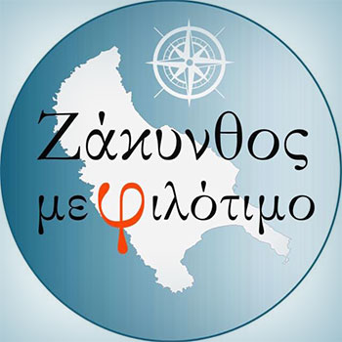

Studied touristic businesses. Independent candidate.
Is captain on a small tourist boat.
We are not professional politicians, but part of society. I am an ordinary citizen of Zakynthos, the idea for the combination came, after frustration and disappointment of indifference, the apathy and incapability of those who have administrated for 30 years.
"We want to first sort out the obvious that remain 'unresolved’ and make our lives miserable. Unfortunately we know the problems that exist in our everyday life. We are citizens who have shown the huge problem of sewage and moved legally, against the Region, for services to work so that the deepening came about up to the mouth of the estuary of Agios Haralambos.
The candidate mayor has prioritized, with the following-
the issue of licenses for all schools,
the money available is from three sources,
a check on all leased buildings housing day-nurseries for their suitability,
the access of pupils with special needs to all school buildings,
the transfer of kindergartens that are located in private areas, could be sheltered, for example, in the old hospital building or other municipal buildings,
to demand the construction of at least two school buildings (primary and secondary ) in town, in order to decongest the already saturated schools,
making use of the study already submitted concerning the repair of ALL school buildings after the earthquake of 26th October, 2018.

We aim to start from everyday life, from improving our lives and that, what is lacking today from citizens.
Reference was also made to the issue of access to the Shipwreck, he fully understands the anxieties of professionals and considers that there is a way to find a solution, if everyone works together.
The hall of the Cultural Centre should be renovated and given for cultural events.

"LIE-EE-KEY SISPIROSI / People Rallying"
led by Fotis Koklas.

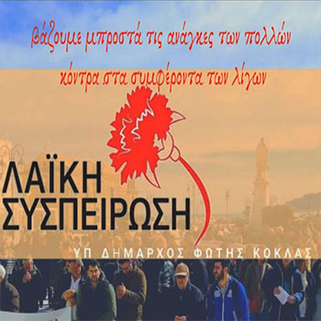

Mr Koklas, growing up, was an athlete of AGEZ in basketball. Is an accountant. Participated in large student demonstrations. He thinks the top moment of social offering is to practice solidarity in our society, especially in emergency situations. Backed by KKE – Greek Communist party.
Priority for us is to fight for -
work for all Zakynthians with rights,
For our children to live better, with modern infrastructure,
to give them outlets to sport and culture, so that they have resistance to any form of dependency,
to feel secure where they are and
to have free education and health.

Priorities, if their combination is elected –
αναγνώριση της προσφοράς όλων των εργαζομένων και συχνή επαφή μαζί τους Ανασυγκρότηση των υπηρεσιών του Δήμου, με.
Frequent discussion of each issue with workers assemblies and village committees.
Reducing the requital charges for families.
Increasing charges to large business groups.

First moves if elected –
termination of seizures of bank accounts of households,
drawing up emergency plans, i.e. after a major earthquake,
check of all school buildings, kindergartens and day nurseries,
maintenance and inspection of sports facilities on the island,
maintenance and inspection of all playgrounds
and the outdoor playing areas, so that they are fully operational.

"MAZEE ALLAZOUME TI ZAKYNTHOS / Together we are changing Zakynthos"
led by George Armenis.

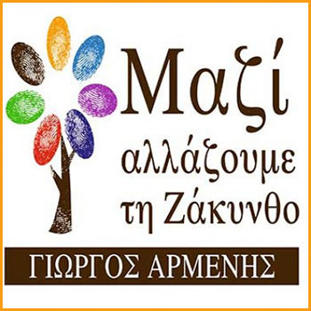

Mr Armenis, has gone into detail of how he is going to proceed with solving the common, to all the combinations, problems of Zakynthos, some are -
Implementing an extensive rodent control programme.
Licensing of an area for the management of aggregate materials and bulky objects.
Underground rubbish bins, especially in town according to the 2014 planning.
Radical reorganization of FODSA services. Expansion of recycling into other materials eg. garage oils, food oils, batteries etc.
Revival and strengthening of Zakynthos Tourist Destination Management Organization "Visit Zakynthos".
Enterprise programme for quality agricultural and rural development – creating QUALITY FOOD AND DRINKS.
"Creative Economy and Culture", particularly important for the younger generation.
To create "smart municipality 'with widespread use of modern technology.
Widespread urban upgrading and traffic relief of town as well as the determination of land uses throughout the island.

"MAY ARETI KAI TOLME YIA ZAKYNTHOS / With Virtue and Boldness for Zakynthos" led by Nikita Aretakis.

Mr Aretakis is a Mechanical Engineer of the National Technical University of Athens.
Mr Aretakis, also known as the ‘islands benefactor’, after funding the planning, building and equipping of a new primary school in the ‘Upper Regions’, near Volimes.
Mr Aretakis is an independent candidate.
He has also stated, that should his combination be voted winners, he will offer his services freely, i.e. he will not be paid.
In the case that his combination does not win, he will return to work, but those of his combination elected will take part in the local administration.
Pursuing (a) Restricting interdependence on the Island. b) The creation of a new generation, which will continue the management of the dimos/municipality. c) Study and reform the requirements of smooth and efficient operation of all Municipal Services. d) Intervene in the infrastructure.
He has promised information on the finances every month, in the presence of television, in the municipality.
Priorities of the combination are:
solving problems in health, the safety of citizens, the fight against corruption, the utilization of the shipwreck, education, conservation and upgrading of tourism and the protection of agro-livestock farming.

"POREE-A PRO-ODO / Progressing Course"
led by Anastasios Marinos.
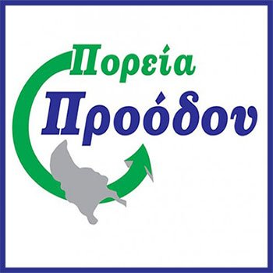

Mr Marinos was elected in 2014, representing Katastari / Alykes area, with the combination of the present mayor, but become an independent councillor after disagreeing with decisions made by the mayor. Mr Marinos remained an independent councillor afterwards.
The programme of Mr Marinos, consisting of 51 points, include -
Reducing municipal fees.
As regards the extraction of oil in the Ionian Sea, we will defend by all legal means the environment and the interests of our country and the municipality, so as not to hit our tourism industry.
Installation of wind turbines in the higher areas of Zakynthos so that the Municipality has reimbursable electricity and we do not pay ‘mounds of money’ to Dei.
Operation of the social grocery shop and restaurant from private sponsorship.
Feeders will be placed in town for stray animals, as they pose a risk to pedestrians and we will go ahead with sterilizations, in cooperation with local veterinarians. Direct consultation with our animal welfare organizations, for the sterilization programme and animal care.
There will be specific points to post a poster, with a view to promoting and projecting cultural or other events.
Licensing the existing playgrounds, the creation of playgrounds in regional locations such as the social housing areas.
The Mayor will pay out of his pocket travel expenses when going outside Zakynthos.
Combat trafficking of goods, in consultation with the Police and the Port Authority.
Learning computers for both young and old, for free.
One of the first actions of the Mayor will be a visit to the Ministry of Tourism so that together we will try to limit "all inclusive" in Zakynthos.
No new hotel will be built in Zakynthos if it does not take care of creating biological cleaning.
We will meet, fully, the criteria and conditions required in order to regain the "Blue Flags" that highlight our coasts, internationally.
Fire protection of our forests will be for us a top priority. The Municipality will undertake the creation of volunteer groups in the villages.

And many more targets.

