ELECTIONS – EKLOYEZ

Part 3

PERIFEREIA – REGIONAL

The Region of the Ionian Islands, with a total population of 207,855 inhabitants, the Regional Council has 41 seats distributed as:
Zakynthos - 40,759 inhabitants and 8 regional councillors,
Ithaki - 3,231 inhabitants 1 regional counsellor,
Corfu - 104,371 inhabitants 20 regional councillors,
Kephalonia - 35,801 inhabitants and 7 regional councillors.
Lefkada - 23.693 residents and 5 regional councilors.

There are 7 combinations for the Ionian Islands perifereia –

AN.ASA
Led by Theodoris Galiatsatos.
Left-wing.

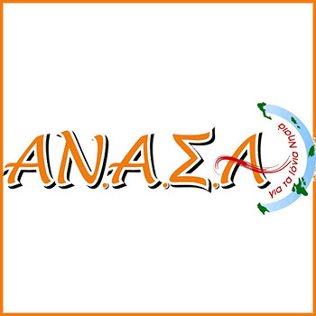

The current Regional Chief Theodoros Galiatsatos, who originates from Kefalonia, who will once again be a candidate, as head of the "Independent Autonomic Cooperation of Authorities - AN.ASA" with the support of SYRIZA (present government).
AN.ASA was not and is not an opportunistic partnership formed two months before the elections and dissolved a few days later.
"We are here for the 3rd consecutive self-governing term, present in the Regional Government of the Ionian Islands, fighting together with the people in our islands, aware of the problems of our country, ready to continue the hard work".

ANYPOKTAKTO IONIA
Led by Stefanos Samoilis.
Far left-wing.

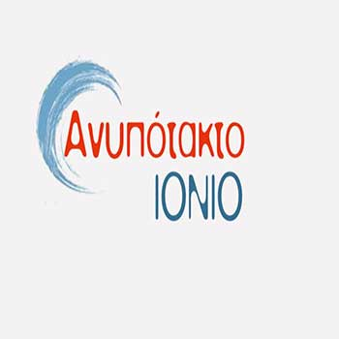

Claiming:
One-digit FPA / VAT for islands
Limitation of All-Inclusive
Stimulation of the agricultural sector
Stimulating local entrepreneurship
Immediately stop research and mining in the Ionian Sea.
No to privatisation
Abolition of ‘Taiped’ and the "Superfund"
We defend the NO of the referendum.

ELLINIKI AVYI
Led by Ioannis I. Aivatidis.
Far-right wing.

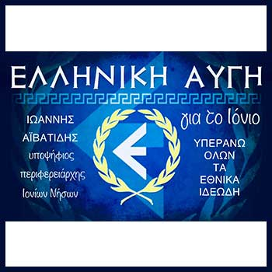

Above all National Ideals.
The goal of "Greek Dawn for the Ionian" is a better tomorrow for our islands.
Aware of our political approach will be the ideological framework of the Peoples Association "Krisi Avyi / Golden Dawn", adapted to the needs and requirements of the self-government.
Our unwavering attachment to the value system of the Greek Nation, is the strongest guarantee of success of the project.
Respect for historians, culture, cultural and environmental values and goods of the Ionian Islands, is the basis of the effort.

IONIAN STRONG Every island high
Led by Rodi Kratsa-Tsagaropoulou.
Supported by Nea Dimokratia, liberal party.

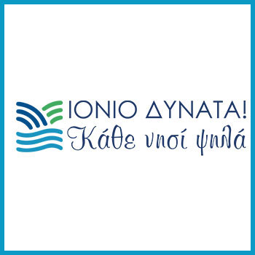

Mrs Kratsa is from Zakynthos.
Mrs Kratsa represented Greece in the European Parliament and was Vice-President of the European Parliament and President of the Institute of Democracy "K. Karamanlis”.
"Our combination moves-on strongly on every island, focusing on all the problems and needs of residents as well as prospects of new growth with a new style and ethos cooperation, teamwork and respect in the common struggle for the mighty Ionian and the potential of each island to go high".

IONIOS SYMMAHIA
led by Spyros Spiros.
Independent candidate.
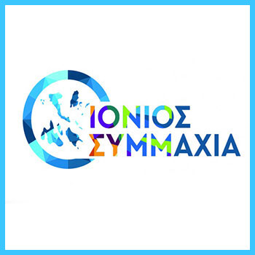

Mr Spiros is from Corfu, was Nomarhis for the same region, from 2010 to 2014. He was the, then, Nomarhis – equivalent to the now Periferarhis, that in 2012 closed the rubbish dump at ‘Skopos’, without first having found another area for the rubbish, resulting in the last three years of problems with rubbish on roads throughout the island and the threat of 30.000+ euro fines from the EU.

“Our goal is to get our islands out of the quagmire and their growth and prosperity to become a reality. Basic infrastructures from one end of our islands to the other have been abandoned and something must be done immediately before they collapse. Road safety conditions, unfortunately, do not even cover the basics, while a number of issues related to other infrastructure, such as water and sanitation, require major interventions. The upcoming elections for the Region don’t have to do with political parties, but are political and self-government, as the problems are common to all those who live and work on our islands.

LIE-EE-KEY SISPIROSI IONIAN NISON
led by Alexandra Balou.
Supported by KKE – the Greek Communist Party.

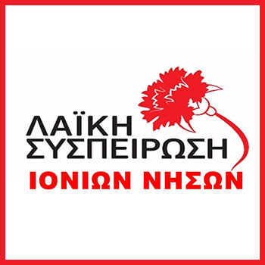

Speaking at different meetings throughout Zakynthos the following have been mentioned:
at Volimes - the problems faced by the inhabitants of the Upper Regions as a whole, with the impending purchase of the area above the shipwreck, the fires that occurred in the same area, combined with the predatory and environmentally dangerous, for the people, extraction of hydrocarbons in the Ionian Islands,
at the village of Skoulikados, at two meetings, focusing on the attack received by farmers and professionals, along with the degradation of the health services provided and the imminent closure of the Health Centre of the area,
once again the timeless efforts of governments to reduce the financing of welfare institutions, to abolish and merge the necessary structures, by extending employment to labour contracts of a certain duration, at the time that they offer irreplaceable work serving permanent needs of guests and their families,
at meetings in the villages of Koiliomenos and Agios Leontas, discussing the desperation of breeders with the closure of the abattoir on the island, the lack of flood protection in Agios Leontas and the under-operation of the doctors clinic.

